

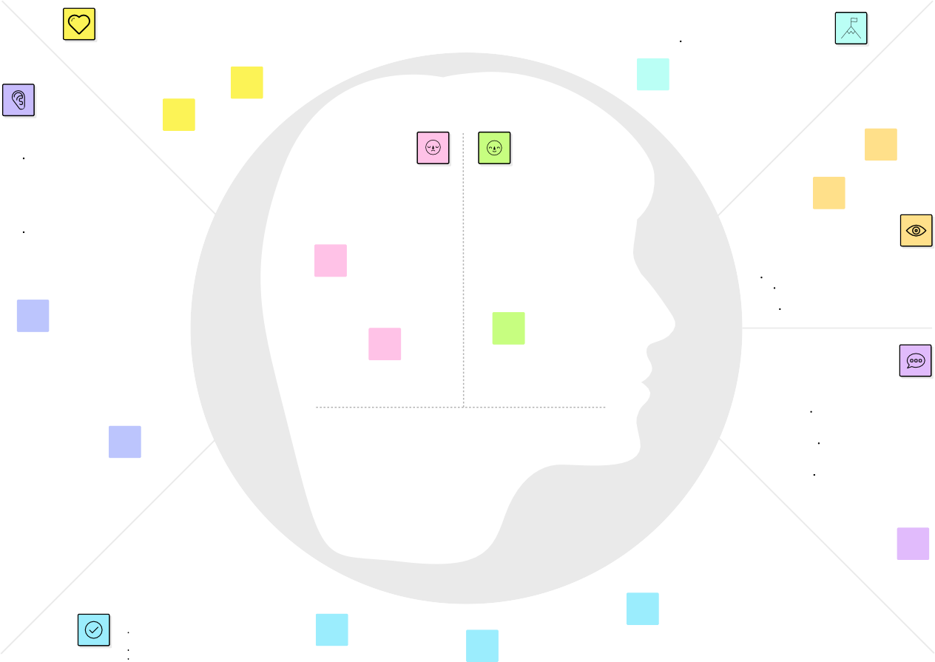
Ideation Phase Empathize&Discover
Developsharedunderstandingandempathy
Summarizethedatayouhavegatheredrelatedtothepeoplethatareimpactedbyyourwork.Itwillhelpyougenerateideas,prioritizefeatures, or discuss decisions.
Empathymap canvas
Creatinganempathymapfor "Globe Trek" involves understanding what your targetaudiencethinks,feels, hears, sees, says, does, and their pains and gains.
WHOareweempathizingwith?
Whoisthepersonwewanttounderstand?What is the situation they are in?
Whatistheirroleinthesituation?
GOAL
WhatdotheyneedtoDO?
1.PlanItineraries:
Theyneedtoplandetaileditinerariesfor their global treks, includingselectingdestinations,bookingaccommodations,andscheduling
activities.
WhatdotheyTHINKandFEEL?
WhatdotheyHEAR?
1.Industry Trends:
Theyhearaboutthelatesttrendsand developments in the travelindustry, such as sustainabletourism, eco-friendly travel, andemergingdestinations.
PAINS
Pains:Financialstrain,travelmishaps,culturalmisunderstandings,languagebarriers,healthconcerns,homesickness.
2,ResearchDestinations:They must research and gather informationaboutpotentialtraveldestinations,including
cultural,visas.
OriginallycreatedbyDaveGrayat
2.TravelNews:
They listen to news related toglobal trekking, including traveladvisories, visa regulations, andupdates on safety and healthmeasures.
GAINS
Gains:Adventure,culturalenrichment,personalgrowth,lastingmemories,uniqueexperiences,friendships,expandedhorizons, and a broaderperspectiveontheworld.
WhatdotheySEE?
Whatimagesorvisualsinspirethemtotravel?Whatdotheyseeasthebenefitsofglobal
trekking?Dotheyhaveavisionoftheiridealtravel
experience?
WhatdotheySAY?
Whatotherthoughtsandfeelingsmightinfluencetheirbehavior?
Safety Concerns: Worries about safety and security in unfamiliardestinations.
DesireforExploration:Astrongdesiretoexploretheunknownanddiscover new cultures.
Excitement:Anticipationandenthusiasmfortheupcomingadventure.
Whatlanguageandterminologydotheyusewhendiscussing
theirtravelplans?Aretherecommonphrasesorexpressions related to their
travelaspirations?Whatdotheysharewithothersabouttheirtravelexperiences?
WhatdotheyDO?
Whatactionsdotheytakewhenplanningaglobaltrek?
How do they prepare for their journeys?What activities and behaviors are commonduringtheirtravels?
Sharetemplatefeedback
Template

Date
TeamID | NM2023TMID05015
ProjectName | GlobetrekInsights-NavigatingGlobalCountryDataWithIBMCognos
MaximumMarks | 4marks

